- Launch a cloud instance (AWS EC2 or Utho)

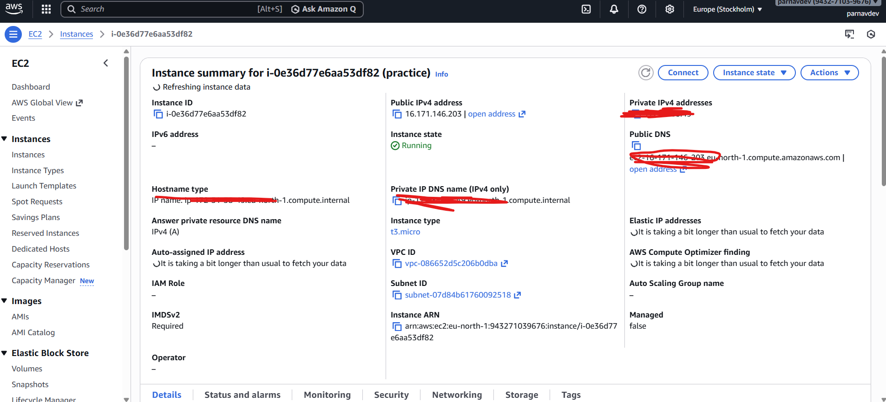
- Connect via SSH

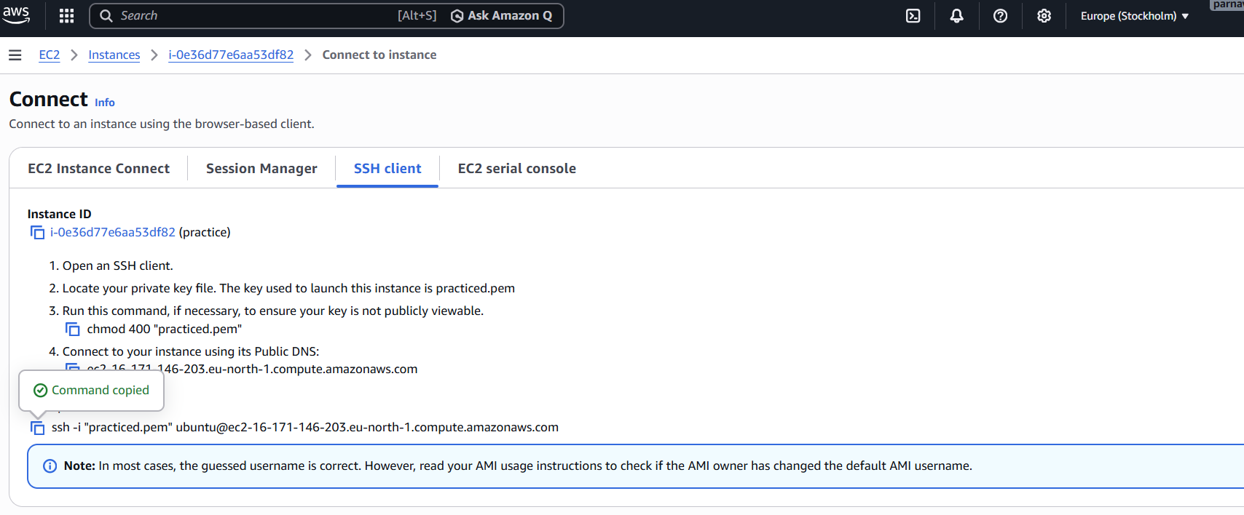

copy the link ssh -i "practiced.pem" ubuntu@ec2-16-171-146-203.eu-north-1.compute.amazonaws.com
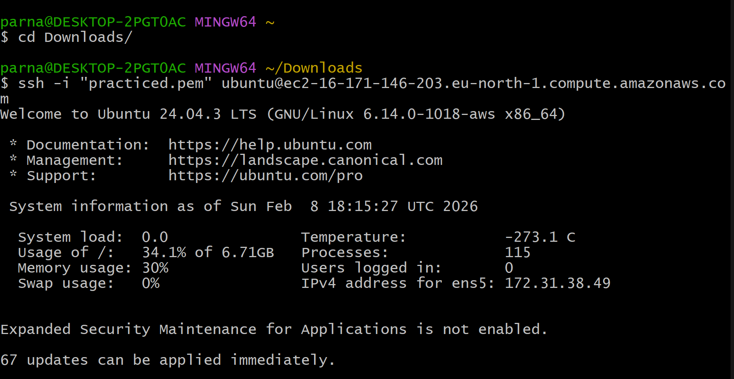
- Configure security groups for web access (port 80 by default for nginx)
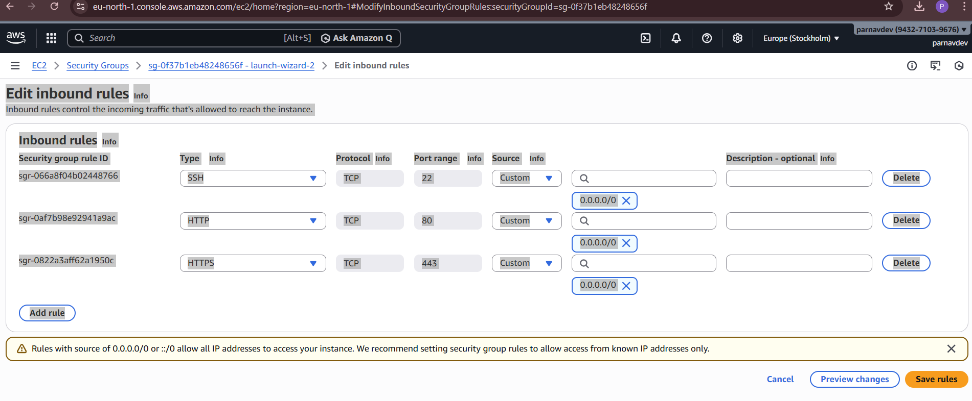

- Verify your webpage is accessible from the internet
